**CURRICULUM FRAMEWORK**

CFW.IAE.EDUCATION

CHANGES & ENHANCEMENTS

1. Course / Branch Name must be a dropdown instead of a text box. (2 hrs) - done
2. Courses / Branches will be entered by super admin to populate in this drop down. (4 hrs) - done
3. So the linking will be changed accordingly. (B.Tech to Civil Engineering, Civil Engineering to Subject Categories) (3 hrs) - done

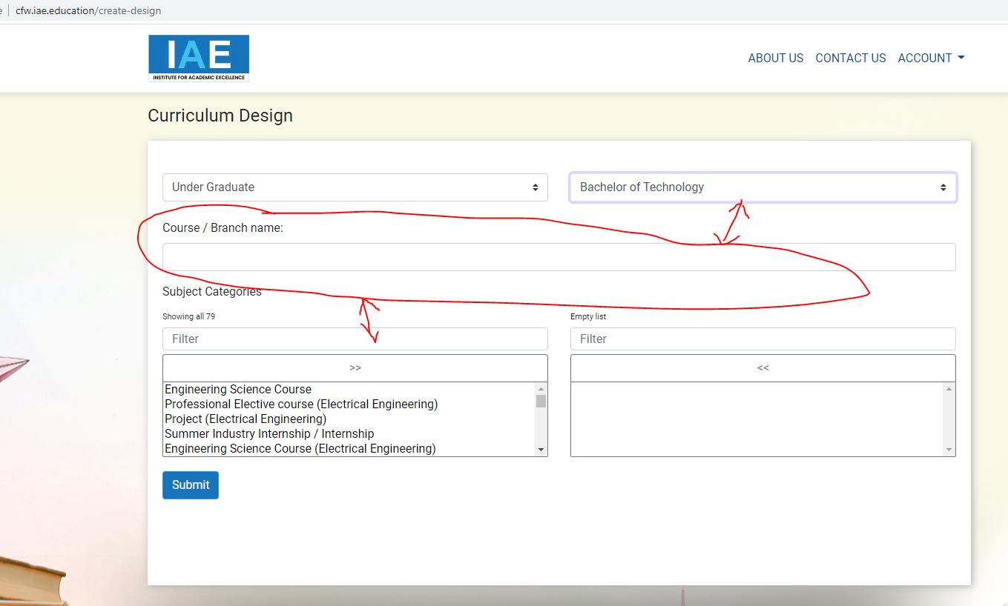

1. Increase the height of those listing boxes. (unable to see the list with in the small box) (1 hr) - done

INCREASE THE HIEGHT MORE THAN DOUBLE - done

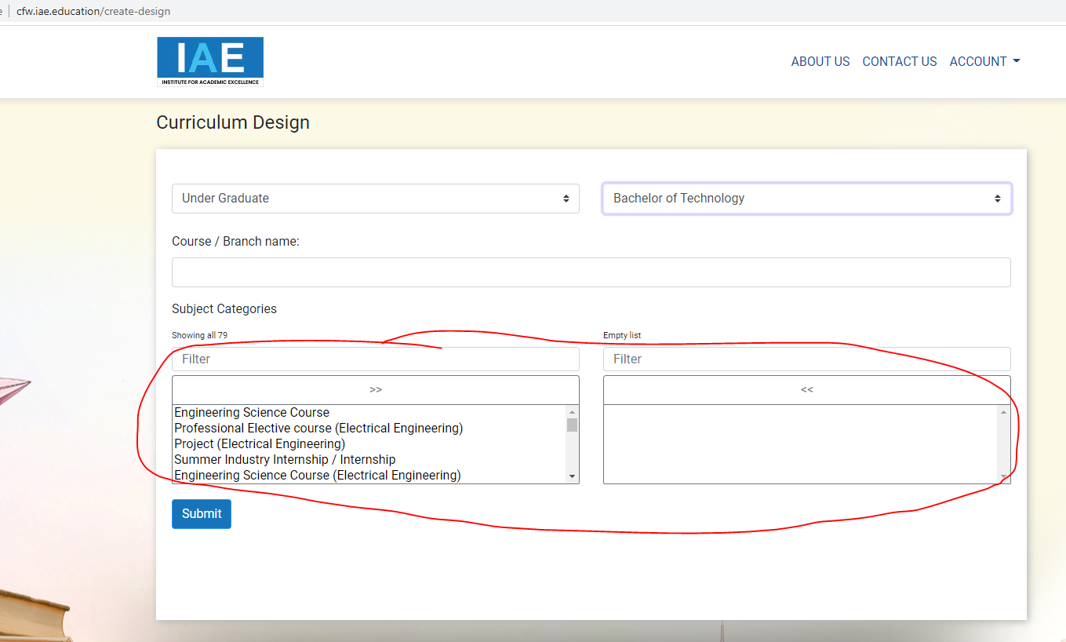

1. Typical Credits are to be shown here which are entered by Super Admin. And the credits entered by the institution should be shown here separately.

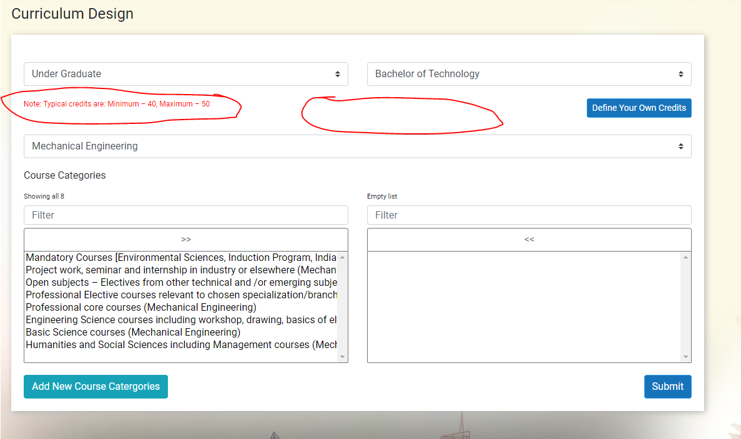

1. There must be an option for user (institution) to add a new value if it is not there in the list. That value must be saved in the master table and shown to all the users. (5 hrs) - done

Add New Branch option should be below the dropdown, (Didn’t find the Branch what you are looking for? Click here to add New Branch) -- done

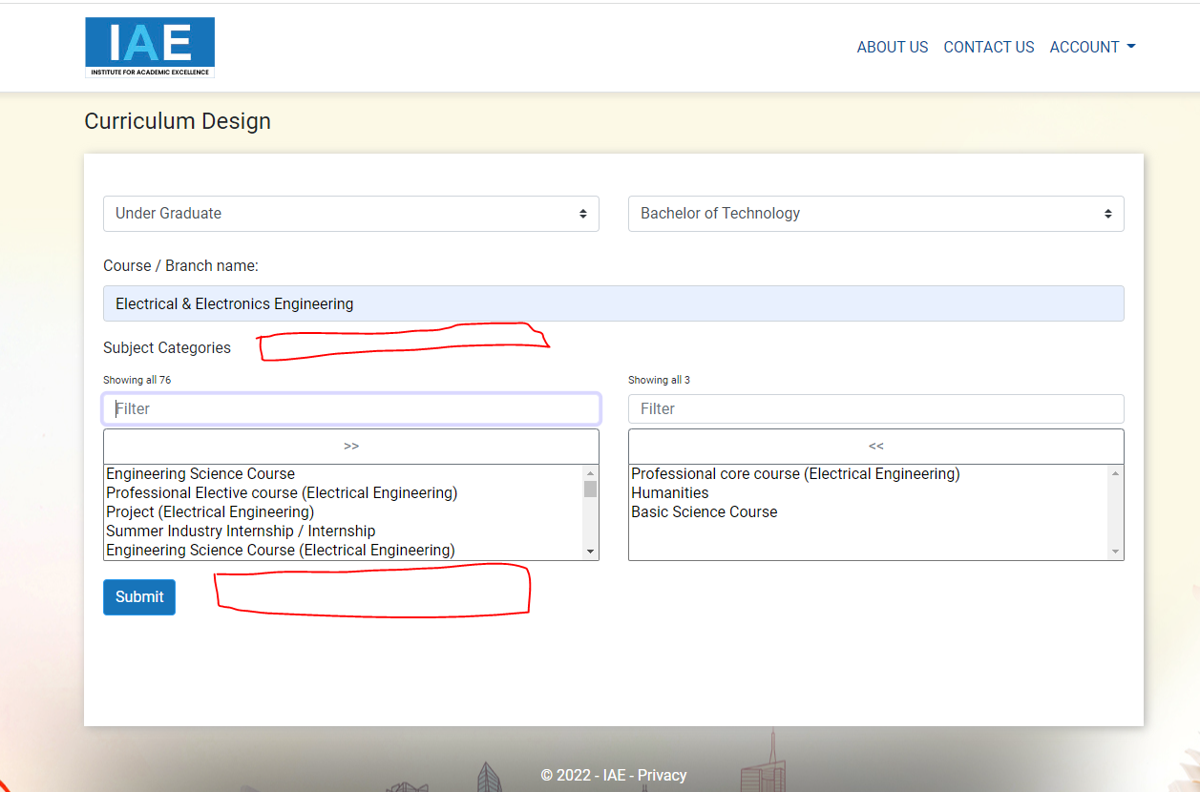

1. In this screen, list is showing in descending order, it should show the first select in serial no.1, second selected in slno. 2… (1 hr)- (NA) PENDING

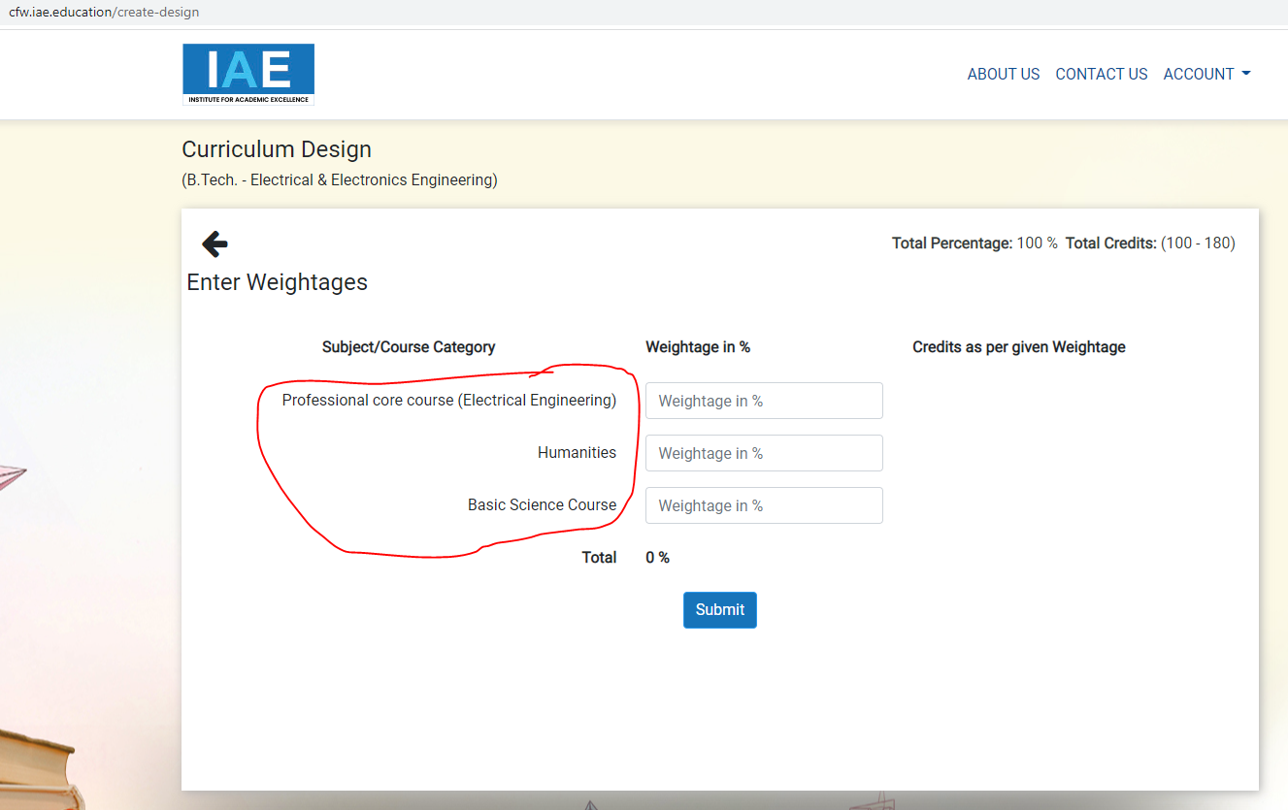

1. Please provide the option to user(institution) to define Minimum & Maximum Credits in the following screen. And consider this for this particular course in the next screens to calculate credits. (10 hrs) – (Done)

Note: Typical credits are: Minimum – 100, Maximum – 180 -> ( update credits in course level & individual inst level)

Define your own credits -> button

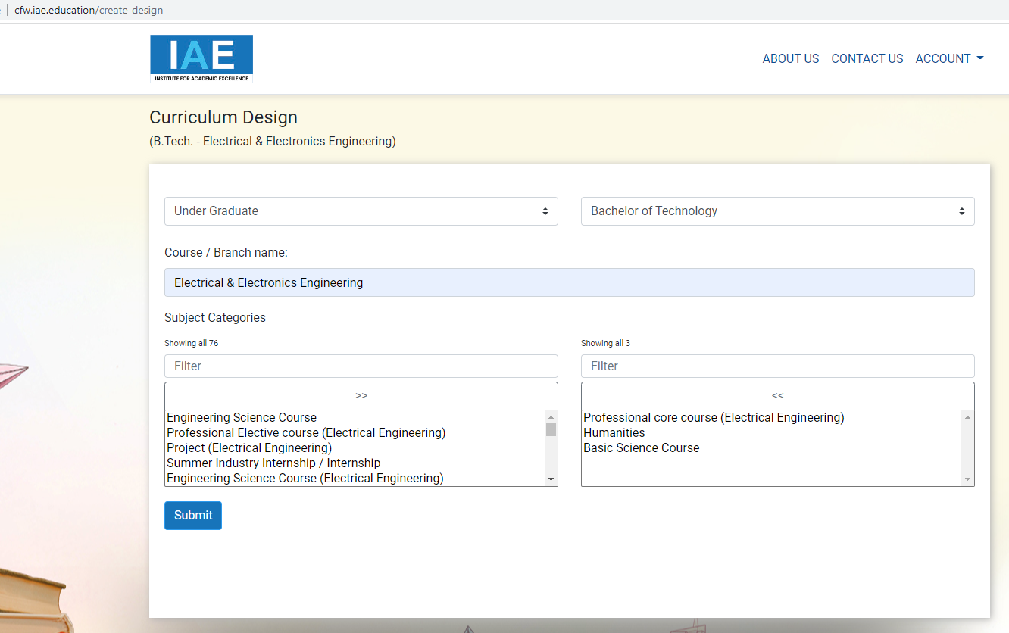

1. Change the text of labels (1 hr) - done
   1. Subject Categories as Course Categories
   2. Filter as Search PENDING -- done

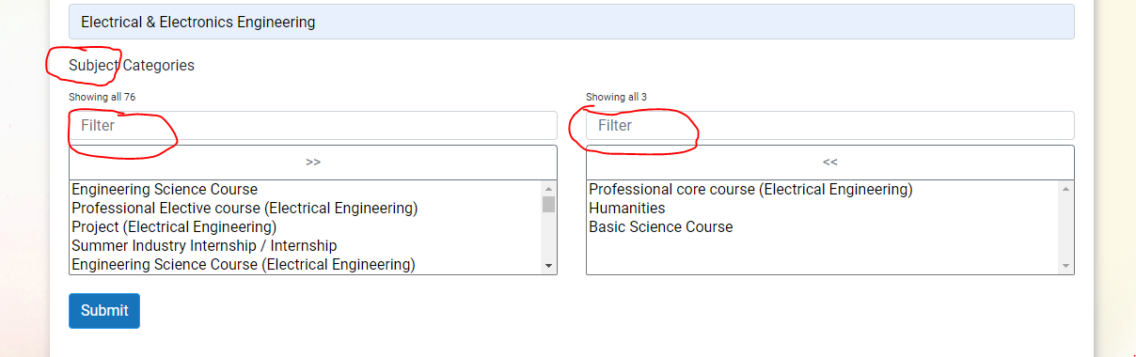

1. **Provision should be given to the user (institution) to define the credits for 1 hour Lecture, Tutorial and Practical. Below is an Example. (6 hrs)**– (Done)

|  |  |  |
| --- | --- | --- |
|  | **Hour/s** | **Credit/s** |
| **Lecture** | **1 =** | **1** |
| **Tutorial** | **1 =** | **1** |
| **Lab/Practical** | **2 =** | **1** |

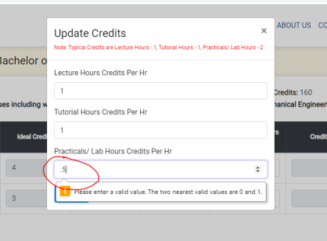

fractions not accepting. - done

1. Please check the Alert message: - done

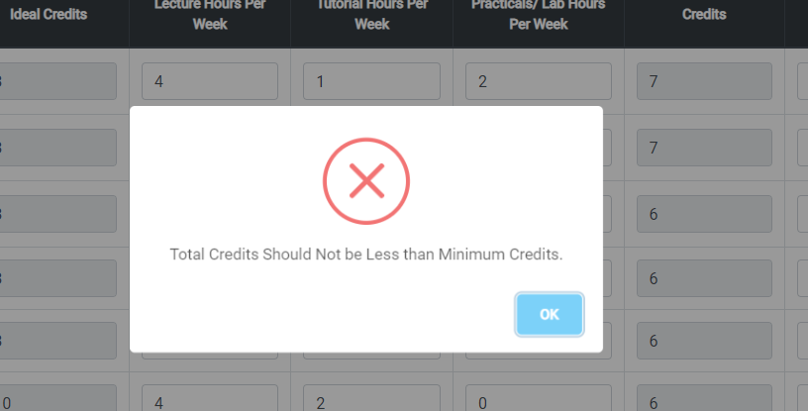

1. In the below screen, it is showing the total of the entered weightages, also show the remaining weightage while entering. (8 hrs) - Done
   1. Also, show a pie graph chart according to the weightages.
   2. Some times Mandatory course may or may not have the credits, consider this for next screens.

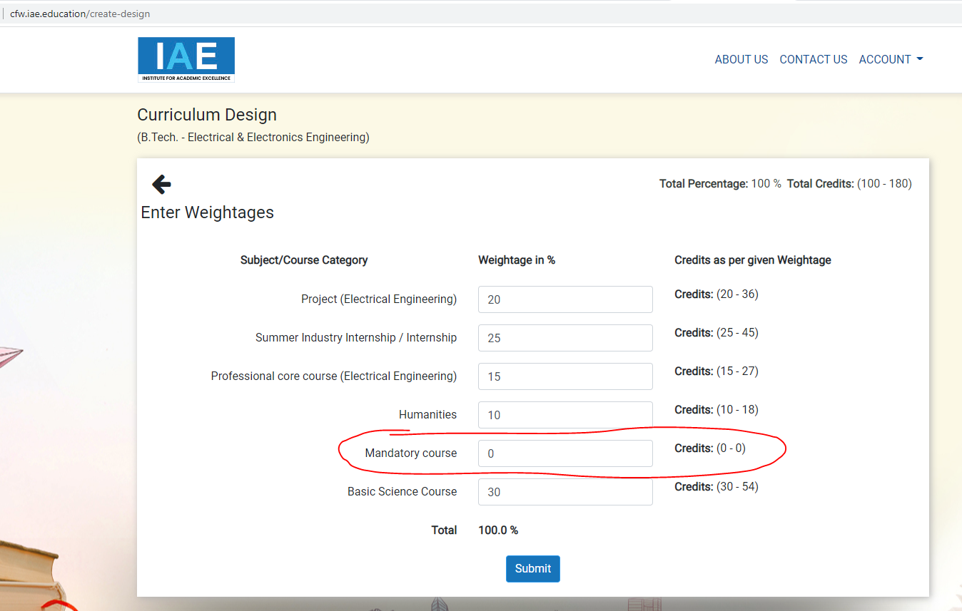

1. In the pop-up, write Course instead of Branch. (30 min)- done

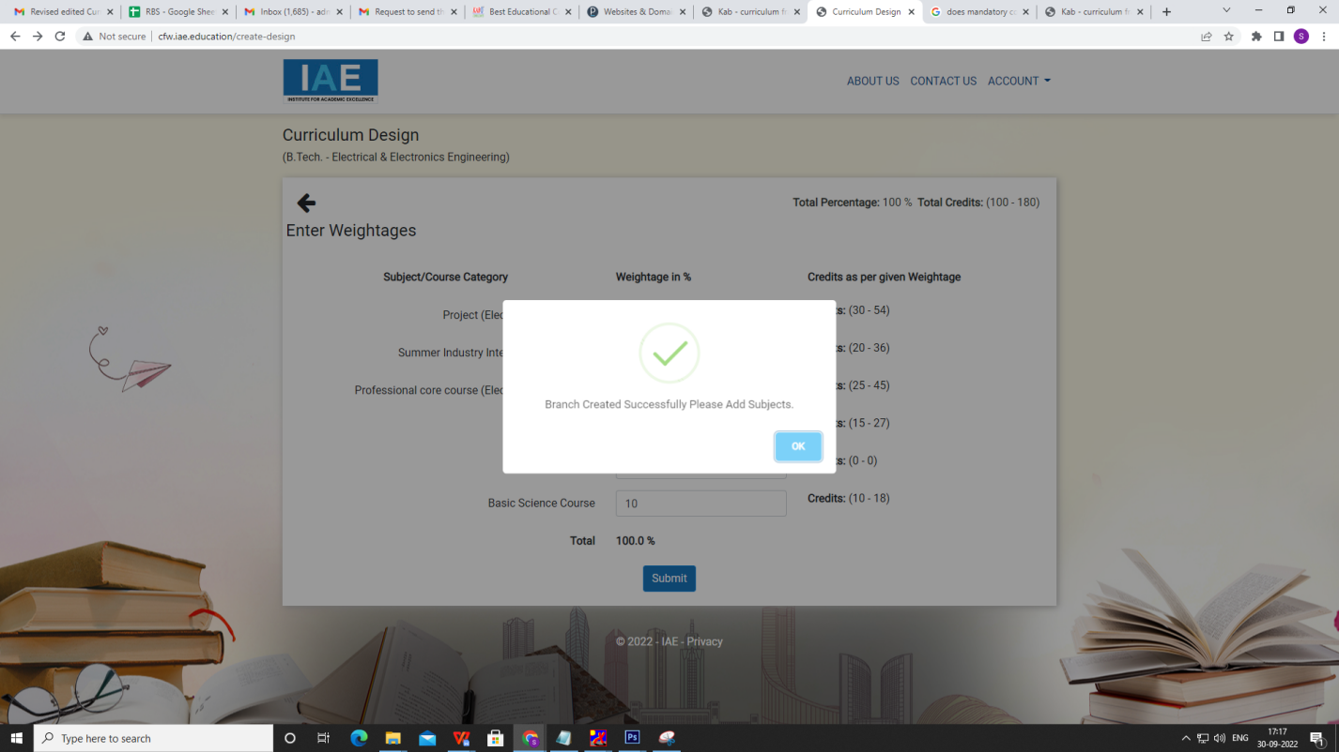

1. In the below screen, Instead of the marked sentence, write ‘Select Subjects’. and those course categories must be displayed based on the selection priority in the first screen. And increase the height of the list boxes(in all pages). (2 hrs)- done

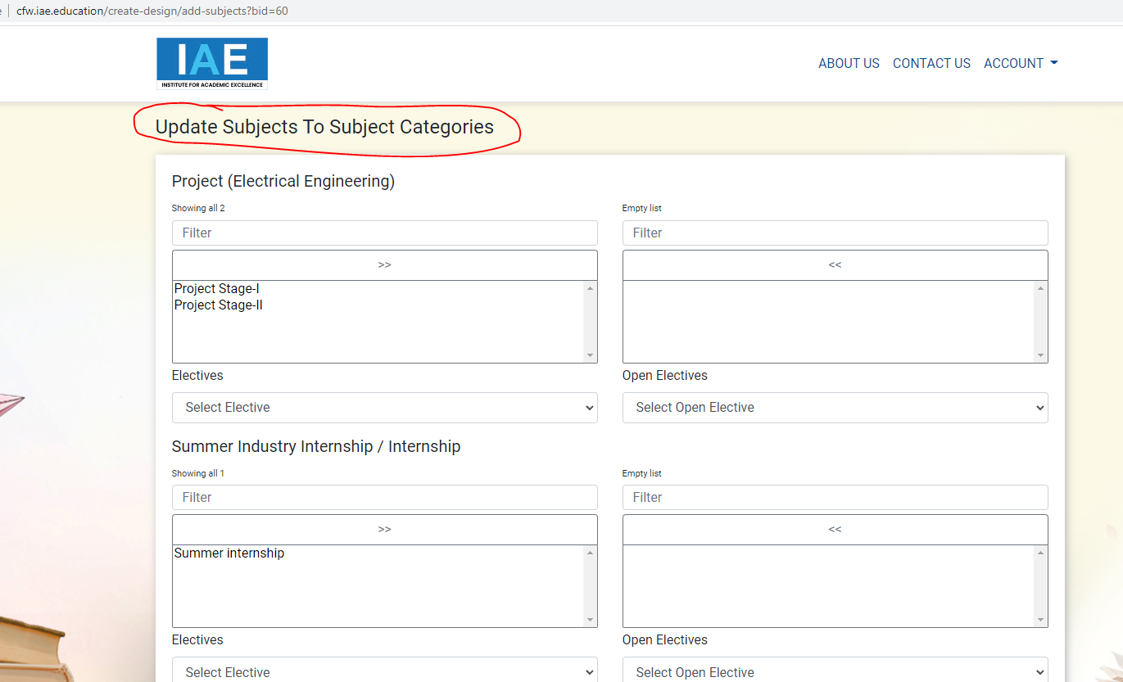

1. In the below screen, provide an option to user to add subjects if not available in the list. Those subjects will be added in master table and visible to other users too. (6 hrs) - done

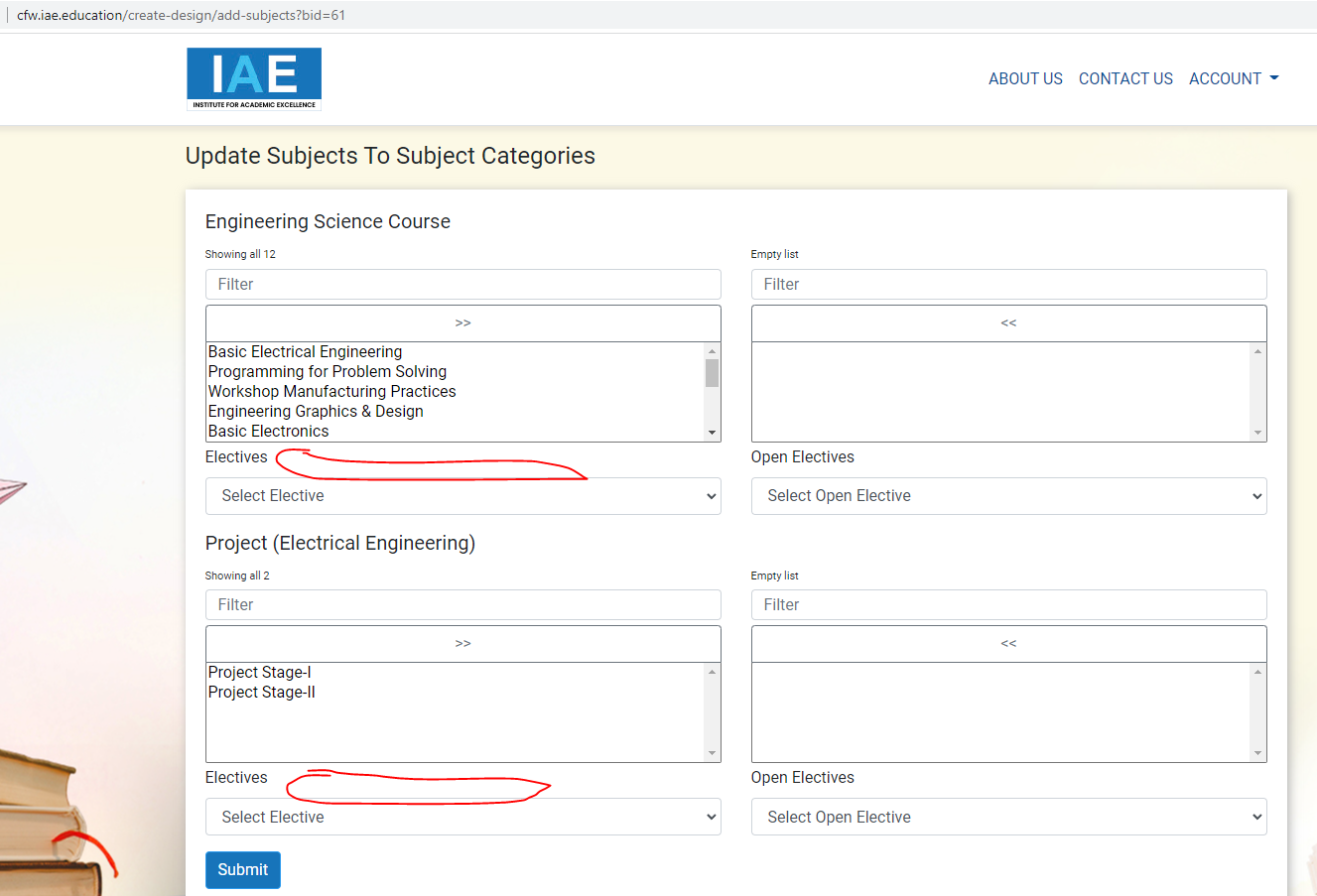

1. There is no back button on any page to go back, Pls provide. Pls save the data in every page other wise if we go back it is going to first page and entire work is not getting saved. If we save the data in every page, user can continue later whenever he get time. (3 hrs) - Done PENDING BACK BUTTON - Done
2. ISSUE: if we enter into edit mode and update the course, then there are few duplicate records showing in the list as shown in below screenshot, showing the same subjects multiple times in subject selection screen, please fix this issue. (2 hrs) - Done

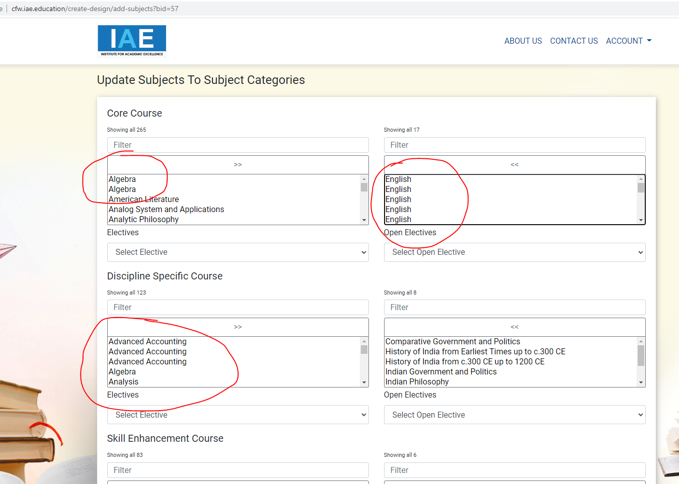

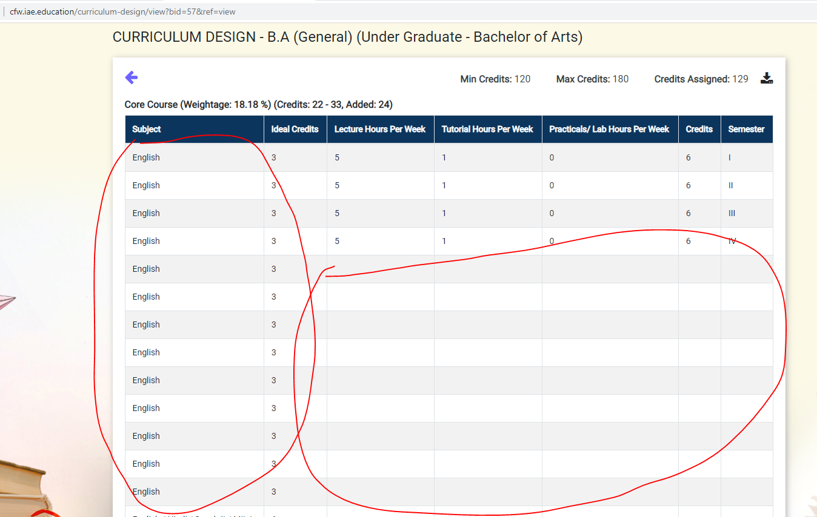

1. ISSUE: if we click on download pdf button, a pdf is download but it is not properly aligned, there is not table and lines, just text is displayed in it, pls fix it. Check the below screen shot. (4 hrs) - Done

DOWNLOAD PDF PENDING - Done

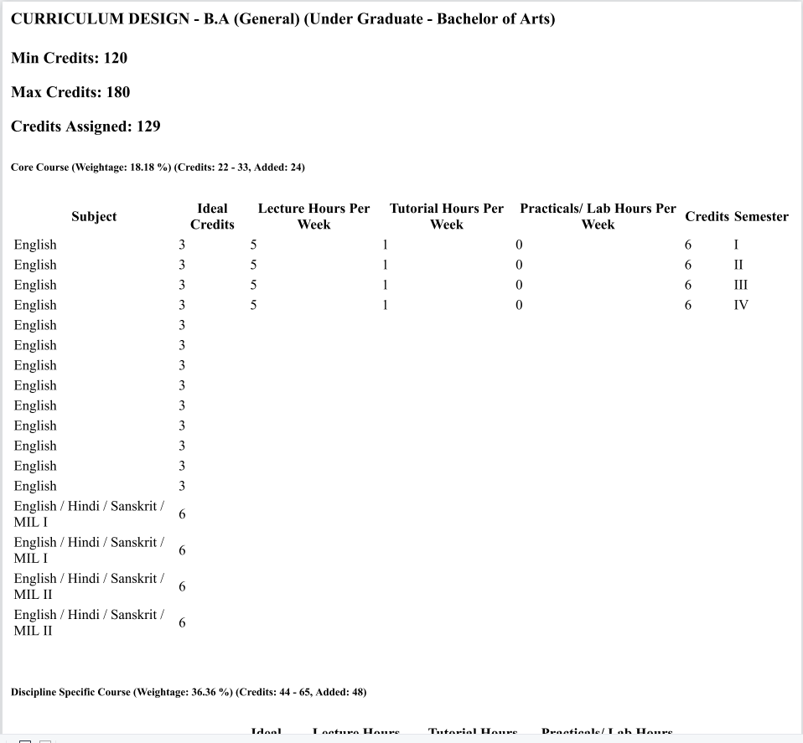

1. Pdf file must show the name of the college. (30 min) - NA
2. Add totals in the semester wise pdf

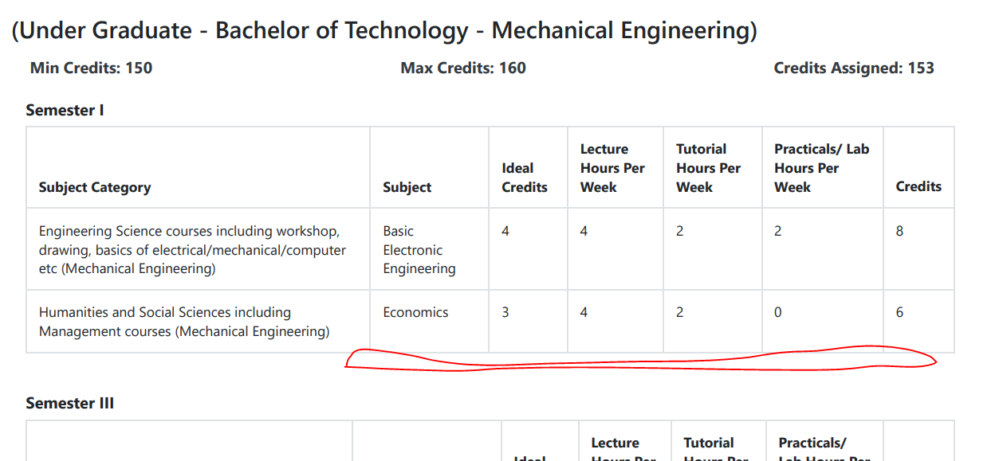

1. Course name must be shown as ‘Under Graduate - Bachelor of Arts - B.A. (General)’ (Program - Course - Course/Branch). (2 hrs) - done
2. And the above pdf is showing the details course category wise. We need another pdf with semester wise. (10 hrs) done
3. Please write the below content in login page below the login button, see the screen shot. (2 hrs) done

------------------------------------

Curriculum Framework-Course Planner

Software Tool for Course Sequencing and Credit Distribution.

Designed to meet the requirements of

1. Multiple Entry and Exit
2. Choice Based Credit System (CBCS)
3. NAAC Framework

-------------------------------------------

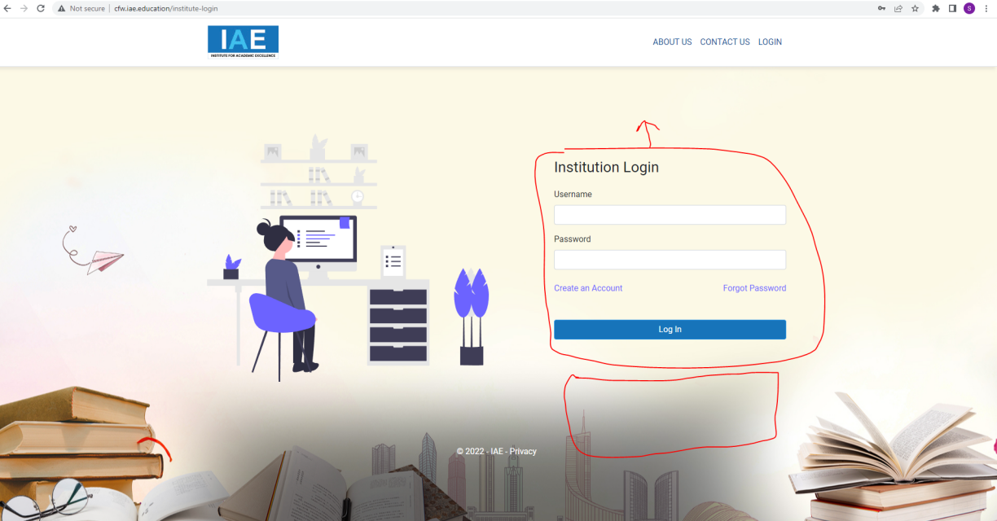

1. While giving provision to user to add course category or subjects the text should be as mentioned below.

Didn’t find what you are looking for? Add here. (With a text box to add it) (1 hr) - done

1. A Note must be there in the weightages page: (2 hrs)- done

*Minor variation is allowed as per the need of the respective discipline.

1. A pop-up alert must be shown when user giving credits to subjects and assigning semesters, in case the credits are exceeding 20 in a semester it should give an alert. (2 hrs) PENDING - done
2. Pop-up while selecting professional electives whether prerequisite is selected in the previous semester or not. PENDING
3. Pop-up while selecting Mini Project - Mini Project should be added between 3rd semester and 6th semester.(4 hrs) PENDING
4. Pop-up while selecting Open Electives: Open electives can be added in 3rd Semester to 6th Semester.(4 hrs) PENDING
5. Pop-up while selecting Economics for Engineer, Environmental studies, HVPE. ‘Please check work load balance for the available faculty.’ (4 hrs)

PENDING

1. Pop-up while selecting Open Elective: Colleges can plan for Track Base / General Pool Open Electives. (2 hrs)

PENDING

1. Pop-up(Instructions): PENDING

**Note:**

Under Graduate Degree Courses in EMERGING / MULTIDISCIPLINARY AREAS shall be allowed as specialization from the same department. The minimum additional Credits for such Courses shall be in the range of 18-20 (including credit transferred from the SWAYAM platform) and the same shall be mentioned in the degree, as specialization in that particular area. For example, doing extra credits for Robotics in Mechanical Engineering shall earn B.E./B.Tech. (Hons.) Mechanical Engineering with specialization in Robotics.

Minor specialization in EMERGING/ MULTIDISCIPLINARY AREAS in Under Graduate Degree Courses may be allowed where a student of another Department shall take the minimum additional Credits in the range of 18-20 and get a degree with minor from another Department.

**Disclaimer:**

Areas in which Minor Degree/Hons. may be offered are numerous. It is up to the Universities with the help of their Academic Board/Council to decide whether Minor Degree/Hons. is to be offered or not in any particular area, which is not mentioned above. AICTE approval is not required for offering Minor Degree/Hons. in any such area, however the criteria that “Minor Degree or Hons. will cumulatively require additional 18 to 20 credits in the specified area in addition to the credits essential for obtaining the Under Graduate Degree in Major Discipline (i.e. 160 credits)”

To maintain the quality of Education, 60% of the eligible courses in any Technical Institution shall be accredited in the next TWO (2) years’ time, else EoA shall not be issued by the Council.

PENDING

1. Pop-up while selecting Professional Core Courses: Professional Core Courses shall be offered during 6th, 7th and 8th Semesters. (2 hrs) PENDING
2. Admin should have a provision to make the curriculum design created by any institute visible with a control in admin panel. So that an institution can see that curriculum in their dash board like sample or a model curriculum. A provision should provided to the institution to use those models If they want to use the same with small corrections and they could be able to modify and save for them. Search facility (Institution shall be able to search by institution or course as per their requirement).PENDING
3. Institution should have a provision to share the created curriculum with a link to other persons to cross check and suggest modification in it. Those modification should be indicated with some color code so the institution will check it again and approve/reject the modifications. PENDING

Note: we will add if we found anything.